Ideation Phase
Define the Problem Statements
Date | 8 October 2026
Student Name | OviyaShree
Project Name | Metro Ticket Generating System in ServiceNow
Maximum Marks

Customer Problem Statement
Problem Statement (PS) | I am (Customer) | I'm trying to | But | Because | Which makes me feel
PS-1 | A metro passenger | Book a metro ticket quickly | Manual counters cause long queues and fare mistakes | Ticketing is not digitized or automated | Frustrated and rushed
PS-2 | A station manager / operations team member | Run ticketing efficiently | Manual handling is slow and error-prone | There is no automated fare collection or ticket record | Overloaded and unsure of accuracy
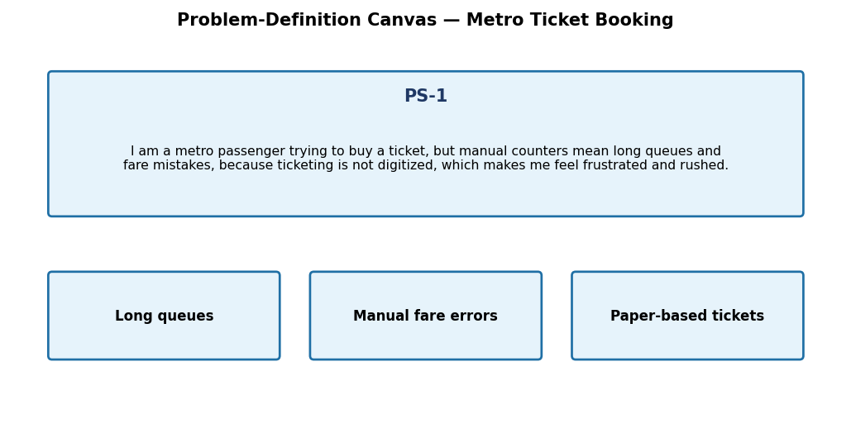
Figure 1: Problem-definition canvas for the Metro Ticket Generating System.

